Lab 12-PostgreSQL
Student’s name: Tao Su

Tuesday, April 29, 2025
Class example:
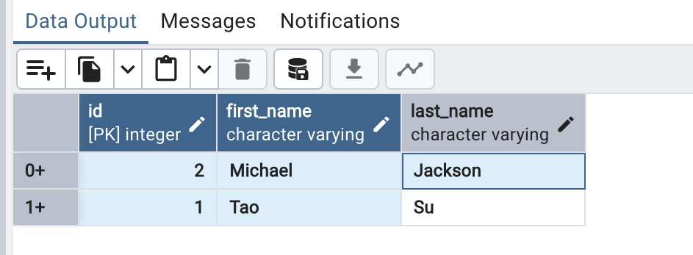
Lab exercise: Manually create a database, table, and columns.
Database: demoDB
Table: courses, tuition
Courses table will have three columns: id(primary key),course_code, (2 characters),
Semester (character varying), schedule(text)
Create two course data entries
Tuition table will have three columns: id(primary key),
pt_credit(numerical),ft_price(numerical)
Create one data entry as for international students.
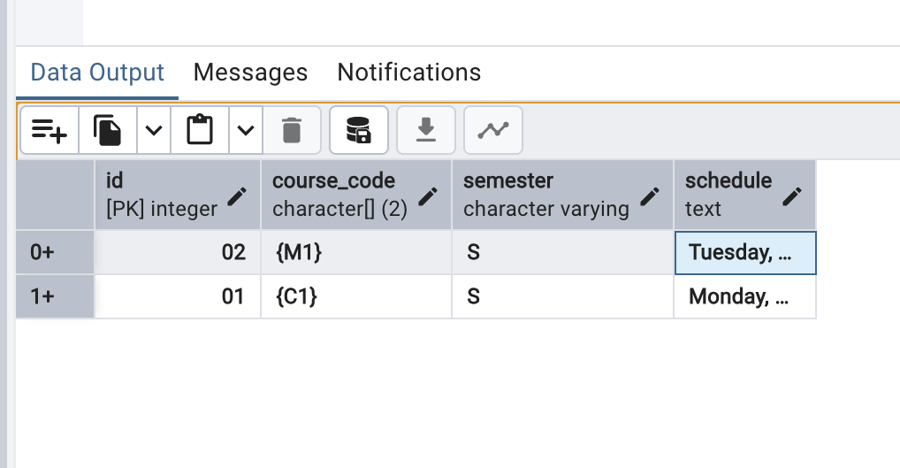
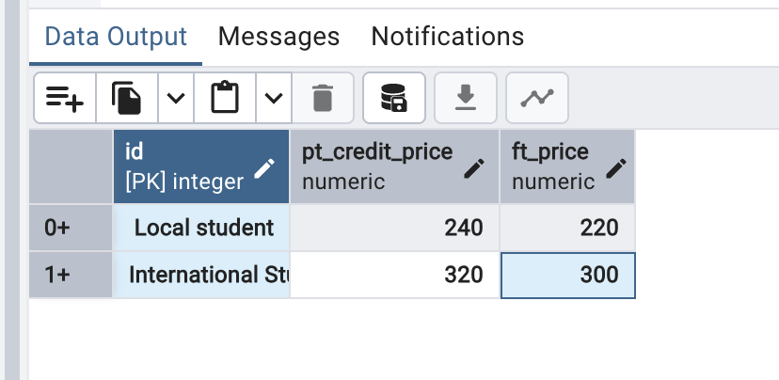

Thursday, May 1, 2025(CRUD)
Class example:
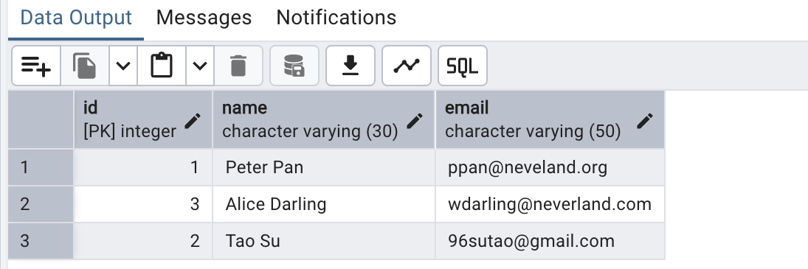
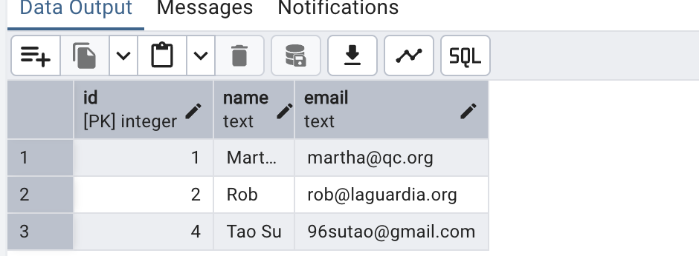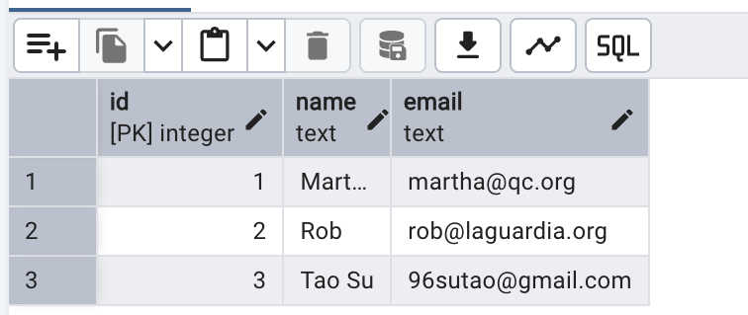
Exercise:
-- 1. Create a table named books with the following structure:
CREATE TABLE books(
id SERIAL PRIMARY KEY,
title VARCHAR(100) NOT NULL,
author VARCHAR(100) NOT NULL,
year_published INT NOT NULL
);

-- 2. Insert records, insert the following records into the books table:
INSERT INTO books (title, author, year_published)
VALUES
('The Great Gatsby', 'F. Scott Fitzgerald', 1925),
('Animal Farm', 'George Orwell', 1945),
('To Kill a Mockingbird', 'Harper Lee', 1960),
('Brave New World', 'Aldous Huxley', 1932);

-- 3. Reda data, write SQL queries to
-- select all books, select books where the author is 'George Orwell':
SELECT * FROM books;
SELECT * FROM books
WHERE author = 'George Orwell';
-- 4.Update data, Update the year_published of Brave New Wrold to 1931.
UPDATE books
SET year_published = 1931
WHERE title = 'Brave New World';

-- 5. Delete data, delete the record for to kill a mocking bird.
DELETE FROM books
WHERE title = 'To Kill a Mockingbird';

- 6. Select all records from the books table to verify your changes.
- 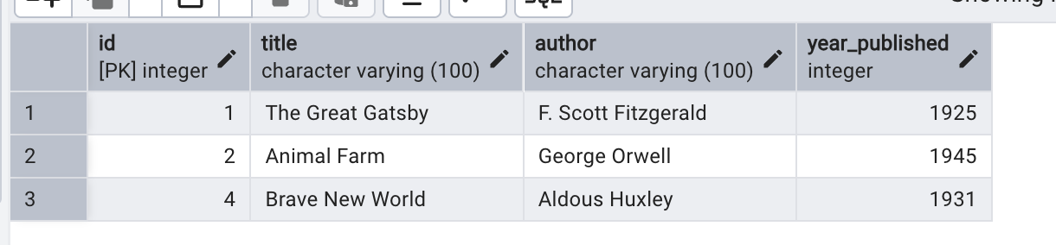

Bonus Challenge:
1.Add a new column genre to the books table
ALTER TABLE books
ADD COLUMN genre VARCHAR(100);
2.Update the genre for each book:
UPDATE books
SET genre = CASE title
WHEN 'The Great Gatsby' THEN 'Tragedy'
WHEN 'Animal Farm' THEN 'Dystopian Fiction'
WHEN 'Brave New World' THEN 'Speculative Fiction'
ELSE genre
END;

3. Select all books grouped by genre:
SELECT title,genre FROM books;

Friday, May 2, 2025
Class example:
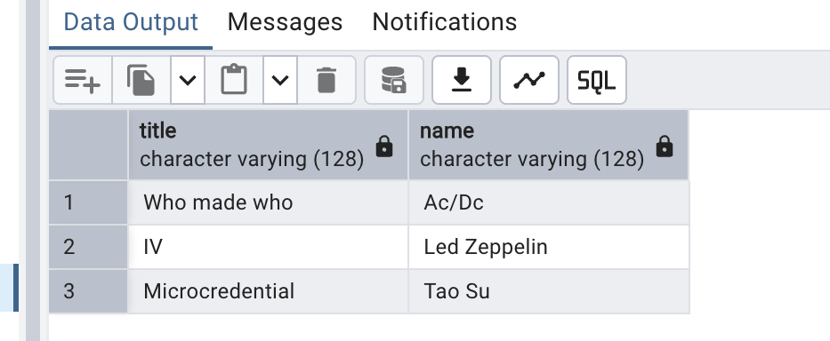

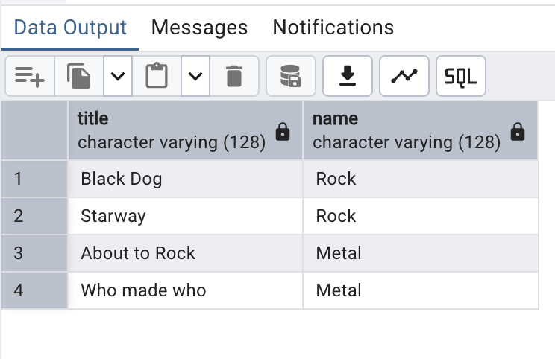

LAB 12C – LAB EXERCISE
Relational database

Activity description: Create a database for a university to manage students, courses, and
enrollments, and practice performing some SQL queries.
Assignment:
• Create three tables:
o ‘students’ table with columns:
▪ id, serial and primary key
▪ name, variant character maximum of 100 characters
▪ major, variant character maximum of 100 characters
o ‘courses’ table with columns:
▪ id, serial and primary key
▪ title, variant character maximum of 100 characters.
▪ department, variant character maximum of 100 characters.
o ‘enrollments’ table with columns:
▪ id, serial and primary key
▪ grade, 2 characters
▪ Foreign key named ‘student_id’ to student’s id
▪ foreign key named ‘courses_id' to courses’ id

• Data entry for each table:
o Four students:
▪ name: ‘Alice Brown’, Major: Computer Science
▪ name: ‘Peter Pan’, Major: Mathematics
▪ name: 'Annie Chen’, major: Physics
▪ name: ‘your name’, major: Mathematics
o Five courses:
▪ title: Database Systems, department: computer science
▪ title: Linear algebra, department: mathematics
▪ title: Quantum mechanics, department: physics
▪ title: Python programming, department: computer science
▪ title: Calculus III, department: mathematics
o Enrollments:
▪ Grade of ‘A’, for ‘your name’
▪ Grade of ‘B’ for Annie
▪ Grade of ‘C’ for Peter

▪ Grade of ‘B+’ for Alice

• Queries to practice

1. read all students and their major
2. read the titles of courses each student is enrolled in.
3. read all students with grade and courses.

